BACKGROUND VERIFICATION FORM CHECK LIST (To be filled by the Client)
[This checklist is mandatory for clients where checks are to be specified for each case or where specific checks need to be conducted from the among the contracted checks e.g. Education Check is mandated but it will depend on the Client whether it is Highest, Latest or any other or Check Mandated is Highest Education and the candidate has completed 2 educations which can fall into the category]

Dear Client,

Kindly tick (√) the checks to be verified. Also, ensure that the candidates provide the documents mentioned against the selected check along with the duly filled JAF.

Important: Candidate is requested to ensure all documents submitted as proof are Self-Attested stating Date & Purpose. [State purpose as ‘employment’]. Attestation should be done along the edge of the document ensuring no key areas of the document are overwritten. This is in your own interest.
Self-attestation ensures your documents are only used for the purpose they are meant for and unauthorized use is dissuaded.
Address Check |  | Documents Required
Address Previous  Address Current  Address Permanent |  | Ration Card/ Passport/ Landline Telephone Bill/ Electricity Bill/ Rent Agreement/ Driving Licence/ Voter ID Card against each address to be verified.
Education Check
10th  12th  Diploma  Graduation  Post Graduation |  | Mark sheet/ All Semester Mark sheets/ Consolidated Mark sheet/Degree /Diploma/ Certificate against each education to be Verified.
Employment Check
Current Employment  Number of Previous Employments  or  Number of years (to be considered for previous employments) | __  __ | Relieving Letter /Appointment Letter /Experience Letter /Last Salary Slip / Resignation Letter against each employment to be Verified.
Reference Check
Current Professional Reference  Previous Professional Reference  Personal Reference |  | For Non-Fresher provide minimum 2-3  Professional References from each Employment.  For Personal References: Persons of repute e.g.: Professor, Doctor, Gazetted Officers are valid.
Database Check
Indian Database
Global Database
Criminal Check
Police Verification - Verbal Police Verification - Written |  | Duly filled and signed CID Form, two Passport Size Photographs and Proof of Address mentioned in the JAF.
Photo ID Check |  | Passport/ Driving Licence / Voter ID Card/ PAN Card
Passport Check |  | Copy of first two and last two pages of the Passport
PAN Number Check |  | Copy of the PAN Card
Character Check
GAP Check |  | Same as Documents required for Address (which need to be verified) and Criminal Verification
Company Check |  | Provide any valid document on Company Letterhead with company address & contact details etc.
CV Validation Check |  | CV of the Candidate
Drug Test
Court Room Check
Others (Specify)
1
2
3
4

BACKGROUND VERIFICATION FORM (to be filled by Candidate)
(Confidential when filled)
ATTENTION: The information you provide in the Background Verification Form (BVF) must be accurate as the same will be used for verification purpose only. Therefore, you are advised to fill the entire BVF with utmost care and attention. Documents provided as proof for the details in the BVF should match. Any mismatch of information/ documents or providing false information may result in the rejection of your offer/termination of employment and action being taken as per the company policy.

Important: Candidate is requested to ensure all documents submitted as proof are Self-Attested stating Date & Purpose. [State purpose as ‘employment’]. Attestation should be done along the edge of the document ensuring no key areas of the document are overwritten. This is in your own interest.
Self-attestation ensures your documents are only used for the purpose they are meant for and unauthorized use is dissuaded.
HOW TO COMPLETE THE FORM
STEP 1 You may need 15 – 20 minutes to complete the form.
STEP 2 Do read all the instructions very carefully. They contain important information about how to complete the application in every respect and the documents that can be submitted as evidence (the information furnished by you would be incomplete without documentary proofs).
STEP 3 Fill the form in BLOCK LETTERS with a BLACK ball point pen ONLY.
STEP 4 Sign the “Authorization Release Note” provided at the end.
Client Reference Number :

PERSONAL DETAILS

1. Name : | Shaikshavali |  |  |  | Niruganti |  | 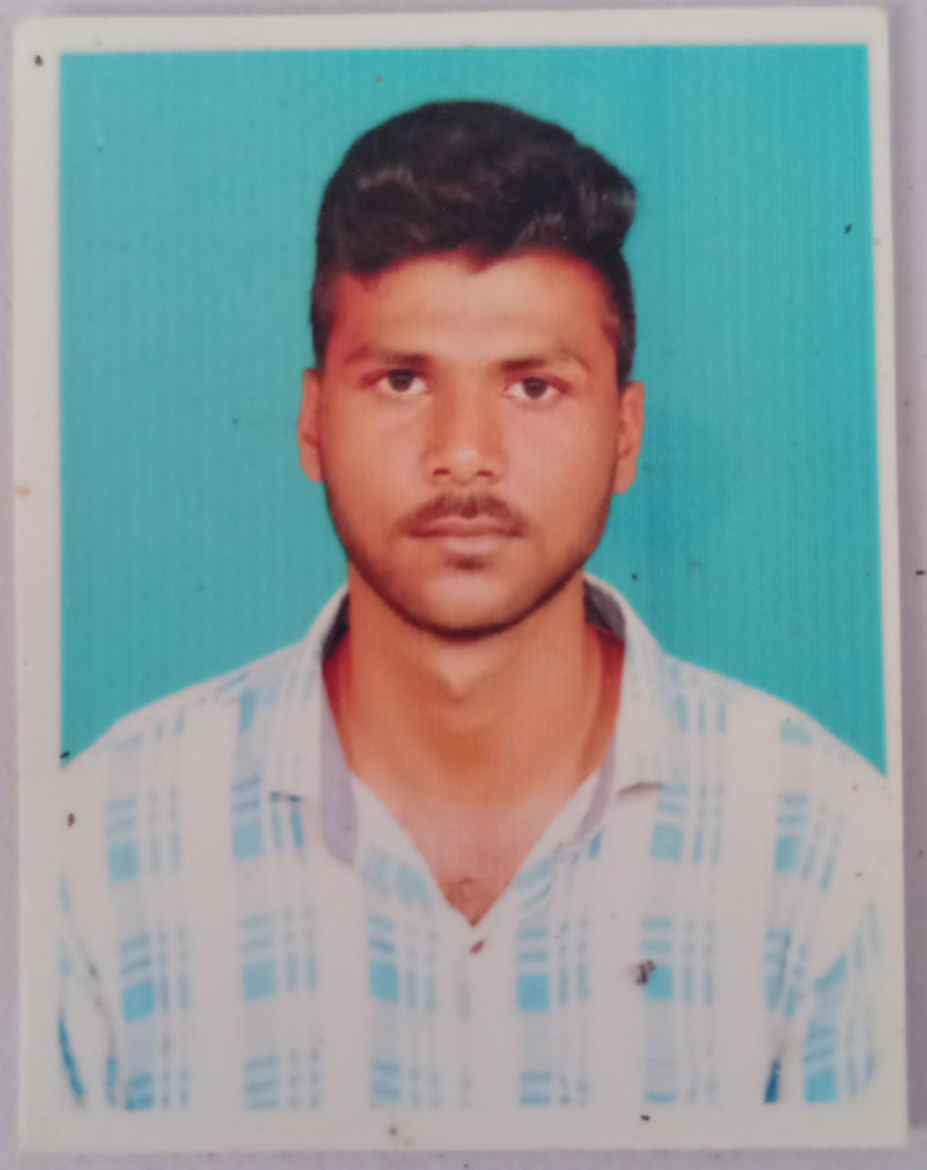
First Name Middle Name Last Name
2. Father’s Name | Peeran Sahib
First Name Middle Name Last Name
3. Alias Name
First Name Middle Name Last Name
4. Date of Birth |  | 5. Place of Birth |  | 6. Gender |  | 7. Marital Status
0 4 0 8 1 9 9 9  D D M M Y Y Y Y |  | Town : Giddalur  City : Giddalur  Country :India |  | Female  Male |  | Single  Married
 |  | 8. Nationality |  |  |  | Single  Married
 |  | Indian |  |  |  | Single  Married

9. Contact Details:
STD/ ISD Code |  |  |  |  |  |  | Phone(Residence)
Mobile Number: | 7 | 7 | 9 | 4 | 8 | 0 | 2 | 6 | 0 | 7 |  | Alternate No. |  |  |  |  | 6 | 3 | 0 | 1 | 6 | 5 | 8 | 2 | 2 | 9
Mail ID | nirugantishaikshavali78@gmail.com

10. Others
Pan Card | B | R | J | P | N | 8 | 4 | 9 | 3 | D
Passport No.(Enclose Copy)
SSN/SIN/EIN No. if applicable

11. Are any criminal/civil proceedings pending against you before a court in India? If so, give name of court, case number and relevant sections of Law.
NO

12. List of Enclosures – Proof of Identity (Kindly tick (√) the relevent box below)
Passport | Voter ID Card | PAN Card | Driving License | Others(Specify)

ADDRESS DETAILS
( Enclose a valid address proof of the address mentioned below
Please use a Photocopy of this sheet for Multiple Addresses)
ATTENTION: The information you provide in the Background Verification Form (BVF) must be accurate as the same will be used for verification purpose only. Therefore, you are advised to fill the entire BVF with utmost care and attention. Documents provided as proof for the details in the BVF should match. Any mismatch of information/ documents or providing false information may result in the rejection of your offer/termination of employment and action being taken as per the company policy.

INSTRUCTIONS
1. Fill in the complete POSTAL Address. All fields are mandatory. Wherever not applicable, please write “NA”.
2. Keep your family members/ neighbors aware of the impending visit for address verification.
3. Duration of stay mentioned as ‘Till Date’ will be considered as date of signing the form.
4. During verification, if it is validated that you were not residing at the address on the duration mentioned, Verification would be declared as NEGATIVE.

1. Address Type | 2. Residence Type | 3. Best day to visit  (Mon –Sat) |  |  |  | 4. Best Time to visit
Current Previous  Permanent | Owned Hostel/ PG Rental  With Relative Parental
5. ADDRESS
Line 1 | Raja Nagar 1st Line,Giddalur,Prakasam Dist ,AP
Line 2 | Sanjeeva Reddy Nagar 8th Ward 1st Line,Giddalur,Prakasam Dist,AP
Line 3
City | Giddalur |  | District | Prakasam
State | Andhra Pradesh |  | PIN Code | 5 | 2 |  | 3 | 3 | 5 | 7
Nearest Landmark
Period of Stay

6. If you are staying in a Hostel/ PG/ Rented House, kindly provide the Name and Contact Details of your Landlord/ Owner/ Warden:
7. State clearly, if the entry is restricted or security Guard/RWA Society etc., is to be contacted for verification of the address provided.
8.List of Enclosures: Proof of address mentioned above (Kindly tick (√) the relevent box below).
Passport | Voter ID Card | Rent Agreement Slip | Latest Phone Bill | Latest Electricity Bill
Ration Card | Driving Licence | Others (Specify)

1. Address Type |  | 2. Residence Type | 3. Best day to visit (Mon –Sat) |  |  |  |  | 4. Best Time to visit
Current Previous  Permanent |  | Owned Hostel/ PG Rental  With Relative Parental
5. ADDRESS
Line 1
Line 2
Line 3
City |  |  |  | District
State |  |  |  | PIN Code
Nearest Landmark
Period of Stay

6. If you are staying in a Hostel/ PG/ Rented House, kindly provide the Name and Contact Details of your Landlord/ Owner/ Warden:
7. State clearly, if the entry is restricted or security Guard/RWA Society etc., is to be contacted for verification of the address provided.
8.List of Enclosure: Proof of address mentioned above (Kindly tick (√) the relevent box below).
Passport | Voter ID Card | Rent Agreement Slip | Latest Phone Bill | Latest Electricity Bill
Ration Card | Driving Licence | Others (Specify)

EDUCATION DETAILS
(Enclose a valid education proof for the education mentioned below
Please use Photocopy of this sheet for Multiple Educations)
ATTENTION: The information you provide in the Background Verification Form (BVF) must be accurate and the same will be used for verification purpose only. Therefore, you are advised to fill the entire BVF with utmost care and attention. Documents provided as proof for the details in the BVF should match. Any mismatch of information/ documents or providing false information may result in the rejection of your offer/termination of employment and action being taken as per the company policy.
INSTRUCTIONS:
- Please fill the form starting with your most recent education first.
- Please enclose a clear copy (both sides) of all Semester Mark Sheets AND Degree Certificates of the education stated.
- If the degree certificate has still not been released then, enclose provisional certificate along with all Semester Mark Sheets.

1. Course Name |  |  | 2. Program |  |  | 3. Completed | 4. Student ID / Enrollment No./ Roll No.
10th 12th Graduation  Post Graduation Other(Specify)______________ |  |  | Full Time Part Time  Correspondence |  |  | Yes  No | 171FA04226
5. College Name & Address  (for the above mentioned education) | Vignan University ,Guntur
6. University/ Board Name
7.Degree Name :Btech  ( Ex HSC, BSC, MA, MCOM) | 8.Subject (Specialisation/ Major)  CSE |  |  | 9. From 2017 |  | 10.To 2021 |  | 11.Graduation date 6/7/2021
12. List of Enclosures: Proof of education mentioned above (Kindly tick (√) the relevent box below).
All Semester Mark Sheets |  | Degree Certificate |  |  | Provisional Certificate
Enclose copy of both sides of all semester Mark sheets and Degree certificate.

1. Course Name (Please tick one only) |  |  |  | 2. Program |  |  |  | 3. Completed |  | 4. Student ID / Enrollment No./ Roll No.
10th 12th Graduation  Post Graduation Other(Specify)______________ |  |  |  | Full Time Part Time  Correspondence |  |  |  | Yes  No |  | 1706233931
5. College Name & Address
(for the above mentioned education)
6. University/ Board Name
7.Degree Name  ( Ex HSC, BSC, MA, MCOM, BTech) | 8.Subject (Specialisation/ Major) |  |  |  | 9. From 2015 |  |  | 10.To 2017 | 11.Graduation date 13/04/2017
12. List of Enclosure: Proof of education mentioned above (Kindly tick (√) the relevent box below).
All Semester Mark Sheets |  | Degree Certificate |  |  |  | Provisional Certificate
Enclose both side copy of all semester Mark sheets and Degree certificate.
13. State if there is any gap between your highest education and your first employment
(Application for experienced candidate)
Yes No |  |  | If Yes, state the gap period below |  |  |  | State the clear reason of the gap below

EMPLOYMENT DETAILS
( Enclose a valid employment proof for the employment mentioned below
Please use Photocopy of this sheet for Multiple Employments)
ATTENTION: The information you provide in the Background Verification Form (BVF) must be accurate as the same will be used for verification purpose. Therefore, you are advised to fill the entire BVF with utmost care and attention. Documents provided as proof for the details in the BVF should match. Any mismatch of information/ documents or providing false information may result in the rejection of your offer/termination of employment and action being taken as per the company policy.
INSTRUCTIONS:
- Please fill the form starting with your most recent employment first.
- Provide valid contact details for your Reporting Manager.
- Wherein the company has ceased its operations, it is mandatory to mention the name and valid contact details of the Reporting Manager / Owner.
- State clearly if your Current Employment is from a Group / Associate Company of a Previous Employment OR your current or any of your previous Reporting Managers are the same.
- Provide atleast 2-3 References for each employment e.g: Reference of a Direct or Indirect Reporting Manager is valid.
- Reference should not be a blood-relative/ family member.

CURRENT/ LATEST EMPLOYMENT
Kindly specify the date Post which the Current Employment should be touched? |  |  |  |  |  |  |  |  |  |  | / |  |  | /
Current Employment would be Verified post the date mentioned above. ANY escalation with reference to Current Employment being conducted post this date will not be entertaned.
1. Nature of Employment |  |  | 2. Self Employed |  | 3. Current Designation |  |  |  |  |  |  |  | 4. Dept. /Project
Permanent Temporary  Agency | Full Time  Part Time |  | Yes  No |  | Official Title |  | Functional Title
5. Payroll Company Name
(as stated on salary slip)
Details | Of Head Office |  |  |  |  | Of location where you have worked  (leave blank if same as head office )
Address
Phone Number
6. Deputed to Company
(Leave blank if same as in point 5)
Details | Of Head Office |  |  |  |  | Of location where you have worked  (leave blank if same as Head office
Address

Phone Number (Board line )
8. Employment Tenure | From Date  (dd/mm/yy) | To Date  (dd/mm/yy) |  | 9. Employee  Code |  | 11.CTC  (Per annum) |  |  | 12. Key Responsibility
8. Employment Tenure |  |  |  | 10. Grade
13. Reason for Leaving:

14. Reporting Manager Details from Current Company (Mandatory)
Name: |  |  |  | Designation:
Is the Reporting Manager still a part of the company? Yes No |  |  |  | Reporting Period
Company Landline/ Board line No. |  |  | Personal Mobile No.
Best Time to Reach:

15. Provide Three References from your Current Company
Details | REFERENCE 1 | REFERENCE 2 | REFERENCE 3
Name

Current Designation

Personal Mobile No.
Email ID
Best time to reach

16. List of Enclosures: Proof of Employment (Kindly tick (√) the relevent box below).
Relieving Letter | Experience Letter | Appointment Letter | Resignation Letter | Last Salary Slip | Other
If knowledge of the document on the basis of which the verification would be conducted in the mentioned organizations then, it is mandatory to provide the same document.

PREVIOUS EMPLOYMENT
( Enclose a valid employment proof for the employment mentioned below
Please use Photocopy of this sheet for Multiple Employments)
1. Nature of Employment |  |  | 2. Self Employed |  | 3. Current Designation |  |  |  | 4. Dept. /Project
Permanent Temporary  Agency | Full Time  Part Time |  | Yes  No |  | Official Title  Engineer |  | Functional Title |  | AI/Analytics
5. Payroll Company Name  (as stated on salary slip) | LTTS
Details | Of Head Office |  |  |  |  | Of location where you have worked  (leave blank if same as head office )
Address | Mumbai |  |  |  |  | Hyderabad
Phone Number
6. Deputed to Company
(Leave blank if same as in point 5)
Details | Of Head Office |  |  |  |  | Of location where you have worked  (leave blank if same as Head office
Address

Phone Number (Board line )
8. Employment Tenure | From Date  (dd/mm/yy) | To Date  (dd/mm/yy) |  | 9. Employee Code |  | 11. CTC  (Per annum) |  | 12. Key Responsibility
8. Employment Tenure | 1/10/2021 | 24/9/2024 |  |  |  | 6,05000
8. Employment Tenure | 1/10/2021 |  |  | 10. Grade
8. Employment Tenure | 1/10/2021 |  |  | 3
13. Reason for Leaving: | Career Growth

14. Reporting Manager Details of your Previous Employment (Mandatory)
Name: | Sandeep Kogge |  | Designation: |  |  | Specialist Manager
Is the Reporting Manager still a part of the company? Yes No |  |  |  |  | Reporting Period
Company Landline/ Board line No. |  |  |  | Personal Mobile No. |  |  | 9960303259
Best Time to Reach: | 9 AM to 5 PM

15. Provide Three References from your Previous Employment (Mandatory)
Details |  | REFERENCE 1 |  | REFERENCE 2 |  |  | REFERENCE 3
Name |  | Sandeep Kogge |  | Suresh Kumar
Current Designation |  | Specialist Manager |  | Manager
Personal Mobile No. |  | 9960303259 |  | 9618229663
Email ID

Best time to reach

16. List of Enclosures: Proof of Previous Employment (Kindly tick (√) the relevent box below).
Relieving Letter | Experience Letter |  | Appointment Letter |  | Resignation Letter | Last Salary Slip |  | Others
If knowledge of the document on the basis of which the verification would be conducted in the mentioned organizations then, it is mandatory to provide the same document.

17. State if there is any gap between any of your employments
Yes No | If Yes, state each gap period below |  | State the clear reason of the gap below

PERSONAL REFERENCE DETAILS
(Applicable only in case of a Fresher)
ATTENTION: The information you provide in the Background Verification Form (BVF) must be accurate as the same will be used for verification purposes. Therefore, you are advised to fill the entire BVF with utmost care and attention. Documents provided as proof for the details in the BVF should match. Any mismatch of information/ documents or providing false information may result in the rejection of your offer/termination of employment and action being taken as per the company policy.

INSTRUCTIONS:
- Provide atleast 2-3 references.
- Reference should not be a blood-relative/ family member.
- For Personal Reference: Person of repute, Eg: Professor, Doctor, Gazetted Officer are valid.

Provide three Personal References (Mandatory)
Details | REFERENCE 1 | REFERENCE 2 | REFERENCE 3
Name
Current Designation

Current Employer

Personal Mobile No.

Email ID

Best time to reach

Given below is the Authorization letter, where candidate needs to sign to authorize for his/her background verification. Candidate has right to deny and not sign the Authorization letter if he/she does not want to allow for verification.

AUTHORIZATION NOTE
‘To whom so ever it may concern’
I authorize the Company or the retained third parties to obtain investigative employment verification report in connection to my application for employment
The employment verification report may include information regarding my character, general reputation, personal characteristics, Education (Authentication of acquired or pursuing Degrees/Diplomas); Employment history; Credit history; court records, including criminal verification records as permitted by law; Passport Verification; Permanent Account Number verification; Drug Test; Finger Print Verification; Address Verification ,references from professional and personal associates as maybe applicable and any other check as found relevant for the profile.
I further understand and agree that the employment verification report may be obtained at any time and any number of times as necessary before, during or post my employment.
I provide my consent to the company or the third parties for the processing of any sensitive personal information obtained for the purpose of verification and call me in case any further information is required.
I understand that some or all of the information I have provided in this application form will be held as digitized or physical records for a period as defined by the data retention norms.
I hereby authorize all previous employers, educational institutions, consumer reporting agencies and other persons or entities having information about me to provide such information to the Company or any other third party/ies retained by them for the purpose.
I understand that the continuance of the employment or the offer of employment is contingent upon the outcome of the background check conducted on me.
The proof of Identity enclosed and self attested for reference. A Photostat, or any other copy, of this instrument bearing my signature shall be equally legally valid as the original.
All the information furnished by me in the Background Verification Form is true to the best of my knowledge.
Signature: 
Name: N.Shaikshavali
Date: 03-10-2024
Place: Giddalur

Note: It is mandatory to duly sign the form on the space provided above or else the application form would be rejected.

